A1339-AM,S-Peru-Chancay-Burial Doll with Serpentine Design-1000-1470 CE

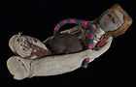

Fig. 1. Peru-Chancay-Burial Doll with Serpentine Design-1000-1470 CE

**Case no.: 7**

**Accession Number: A1339 (AT6)**

**Formal Label:** Peru-Chancay-Textile with Feline Heads-1000-1470 CE

**Display Description:**

The Chancay civilization that produced this artifact developed between the Chancay, Chillon, Rimac and Lurin Valleys, on the central coast of Peru between 1200 and 1470 CE. Its center was located 80 km. north of Lima. The territory occupied a coastal region interspersed with rivers flowing down fertile valleys which provided the opportunity for agricultural development, population expansion and craft specialists such as ceramicists and weavers.

This Chancay polychromatic “burial ‘doll” is not a “doll” in the commonly understood sense that it is a “toy.” Rather, it is a “textile figurine,” which is how we will refer to it here. A “textile figurine” is similar to a “ceramic figurine,” in that it represents a gendered anthropomorph (a human, a deity or an avatar) that was placed in tombs to provide the deceased with companionship and guidance on their journey to the hereafter. This particular “textile figurine” has fabrics with a serpentine-wave motif. The hammock in which this individual textile figurine rests is of a thin gauze-like structure and wrapped in many folds (see Feltham 1996: 440). Since this fabric was used as an apotropaic vestment for the entombed funerary cloth doll figurine, the serpentine motif in the fabric is consistent with the Chancay belief that serpents were protectors of the deceased. Funerary Chancay cloth doll figurines were wrapped in these serpentine textiles and placed around the mummies not only as accompaniment to the afterlife but also as protectors on the journey to the beyond.

**LC Classification:** F3429.1 C47

**Date or Time Horizon:** 1200 and 1470 AD/CE

**Geographical Area:** valleys of Chancay, Chillon, Rimac and Lurin, on the central coast of Peru

**Map, GPS coordinates:**

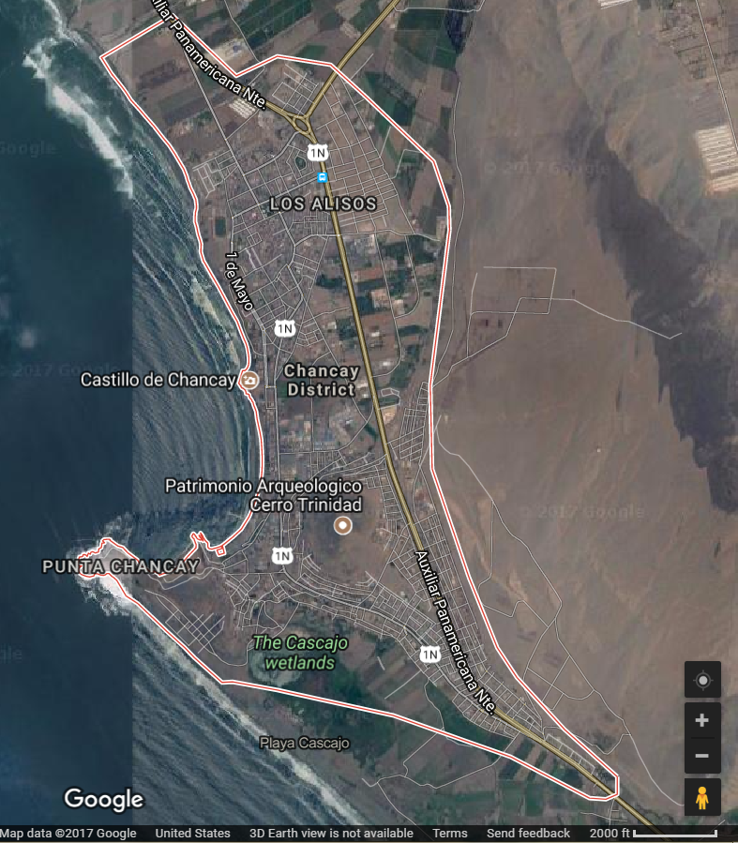

**Fig. Map of Chancay Cultural area after Google.com**

**Cultural Affiliation:** Chancay

**Media:** alpaca wool, vegetable dyes..

**Dimensions:** H 9 in, W 4 in.

**Weight: 94 gm, 3.25 oz**

**Condition: original**

**Provenance:** unknown.

**Discussion:** Chancay culture’s textile art was inherited from the Paracas culture (800 BCE-200 CE), which is reflected in the fabrics in which the dead were wrapped. The present textile specimen incorporates a serpentine motif in both the red and gold border and the blue and gold ground motif. Some funerary dolls seem to evoke specific individuals who were dear to the deceased. In addition to this single individual in a hammock, the Atlantika collection has a doll with two individuals dressed in ancient Chancay apparel and wrapped in their own hammock to accompany the deceased on their afterlife journey, so multiple individuals could accompany the deceased is desired!

**References:**

Banco de Crédito del Perú. 1982. *Culturas precolombinas: Chanc*ay. Lima, Perú: Banco de Crédito del Perú.

Feltham, Jane. 1996. “Chancay.” In *The Dictionary of Art*, Jane Turner, ed. London: MacMillan: 440.

**AP: .14**